HA KY LAM

A SEA ESCAPE

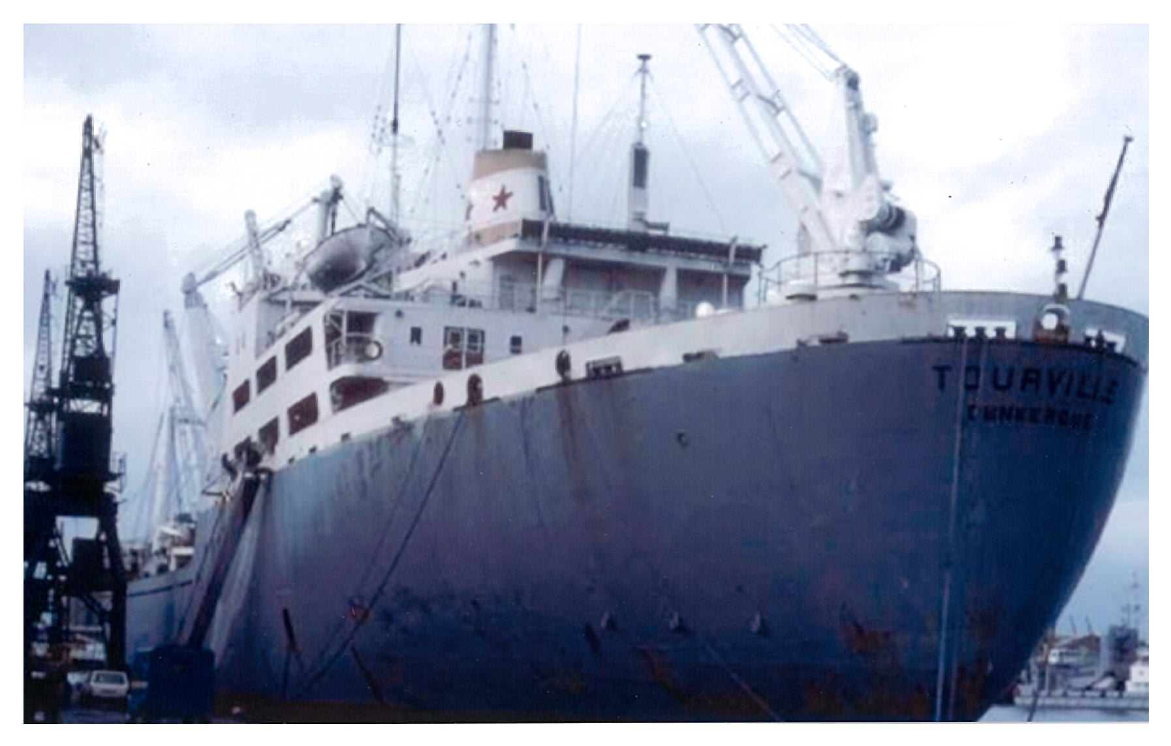
MV Tourville of the maritime company Chargeurs Reùunis

FACTS BEARING ON THE VIETNAMESE BOAT PEOPLE

- Vietnamese boat people refers to refugees who fled Vietnam by boat and ship after the Vietnam war, especially during 1978 and 1979, but continuing until the early 1990s.
- Boat people had to face storms, diseases, and starvation, and elude pirates. The boats were not intended for navigating open waters, and would typically head for busy international shipping lanes some 240 km to the east. The lucky ones would succeed in being rescued by freighters or reach shore 1-2 weeks after departure. The unlucky ones continue their perilous journey at sea, suffering from hunger, thirst, disease, and pirates before fnding safety.
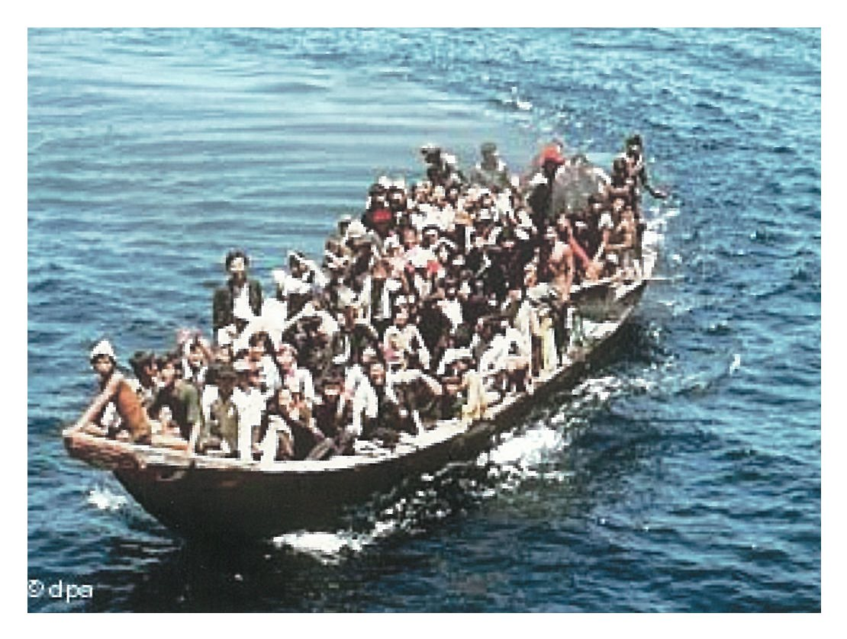
Boat people had to face storms, diseases, and starvation, and elude pirates…

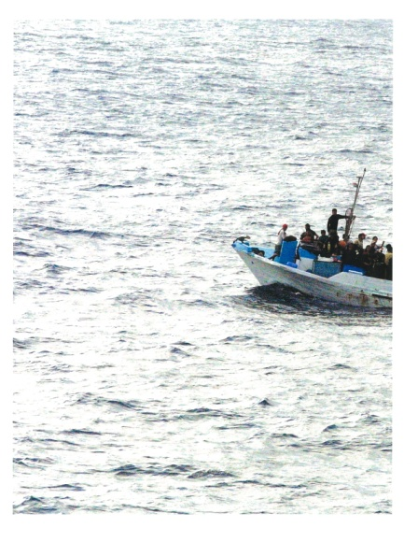
The boats were not intended for navigating open waters and would typically head for busy international shipping lanes some 240 km to the east…
- According to the United Nations High Commissioner for Refugees, the increasingly repressive policies of Vietnam caused the exodus of approximately 840,000 Vietnamese people to neighbouring countries.
- The United Nations High Commissioner for Refugees also reported that at least 250,000 Vietnamese people lost their lives at sea during the exodus of the Vietnamese boat people due to drowning, illness, starvation, and piracy.
- The mass flight of hundreds of thousands of boat people from Vietnam in 1978 and 1979 caused an international humanitarian crisis with the Southeast Asian countries increasingly unwilling to accept boat people on their shores.
- In July 1979 the United Nations convened an international conference in Geneva, stating that a grave crisis exists in Southeast Asia for thundreds of thousands of refugees. Illustrating the prominence of the issue, Vice President Walter Mondale headed the U.S. delegation. The results of the conference were that the Southeast Asian countries agreed to provide temporary asylum to the refugees, Vietnam agreed to promote orderly departures, and the Western countries agreed to accelerate resettlement.
- The United Nations High Commissioner for Refugees (UNHCR) has helped 34 million refugees rebuild their lives since its inception in 1950.
- From 1975 to 1979 about 5,000 Vietnamese refugees landed in Singapore through commercial ships who picked them up in the open sea.
- Using the site of a former British army barrack, in 1978 the UNHCR set up the Vietnamese Refugee Camp in Sembawang, Singapore, to accommodate those refugees.
- By the end of June 1996, the Vietnamese Refugee Camp in Singapore was officially closed, after the last batch of 99 boat people, living there since 1990, was voluntarily repatriated to Vietnam.

A SEA ESCAPE
By Ha Ky Lam

“Of the thirty-six ways of escaping, to run away is the best.” That ancient Chinese saying often came back to the mind of the Vietnamese desperate under the new rule by the communists after the Republic of Viet Nam (South Vietnam) lost the war in April 1975. And escape by sea was the way adopted by the majority of the Vietnamese attempting to flee the country, including my family. Our escape from Vietnam was a queer journey with all its deadly contingencies. If it had not been for freedom and for the opportunities for our children to live in a society where human rights and other values of man would be guaranteed to all, we would not have taken such a risk, and would not have made the painful decision to leave behind things and people so dear to us.

A DECISION THAT WAS HARD TO MAKE.
Weighing the pros and cons of departure and stay was never easy for us. On one side, the prospect of a new horizon where freedom, opportunities, value of man as man regardless of creed, etc.. seemed assured to everybody had a compelling attraction. On the other, the hardest part was for my wife to part with her 70-year- old mother whom she loves so much. She did not want to go with us, being afraid that she could not put up with all the hardship of the trip. And no one could tell when we would be back – if we would ever have a chance to do so at all – to see her. There were also such things as the dangers of sea travel, new place, new custom, new culture, new language, etc.. We wondered whether we could make it, and then could cope with those problems in a new society. But after all, we had to leave, because of freedom and opportunities for our children. And we made a painful decision – maybe a right one.

AT THE PLACE OF DEPARTURE.
Every minute at the place of departure seemed days, months, or years. My wife, our two children, aged 8 and 10, my brother-in-law, my wife’s 11-year-old nephew, my wife’s cousin, and I, together with other people had to hide in the forest along a chosen coast for three days in wait for the boat which would be brought in by one member of our group. The boat was scheduled to come in a day after our arrival at the place. Due to the situation en route, it had not made it until the third day of our hide. Although we were informed of the delay, none of us could relax. Everybody started worrying about being detected and being caught by coast guard patrols. I tried my best to keep my companions confident by talking about my experiences in critical situations I had encountered before, while it was ironical that I myself did not believe much in what I said. The intuition of a former soldier made me think that our escape plan was going awry. Situations of this kind are similar to those in combat. Time at the target area must be as precise as possible or everything would be ruined. The worst thing was to stay around there too long. But there was no way for us to withdraw without being captured. All we could do then was to stay and pray that everything would be allright and that the boat would come. Jungle mosquitoes, insects, hunger, thirst, all added up to make things more miserable for us. Finally, at about 5 pm on the third day of our expectation, the boat came in triumphantly. Many of us cried of joy and of mixed feelings. We bade farewell to Viet Nam, may be for good.

AT SEA.
The ocean was so immense and so merciless. We were a group of 54 people – men, women, and children – on a tiny powered topless wooden boat measuring about 8 meters (24ft) long and 1.6 meters (5ft) wide. We were packed like sardines. Our little boat pitched and rolled over the angry waves. The boat was overloaded, and we were just less than 2 feet (about 50 cm) above the water, and every time a wave came, it splashed us all over. But, thanks goodness, the sea in those days was not very rough. The sun shined most of the time. We sailed for three days in the direction of Malaysia with very little potable water in our boat. We had brought with us only 10 gallons of water for 54 people. As I mentioned above, our boat had had difficulty en route to the place of departure. In order to easily pass the Communists’ checkpoints, our pilot had dropped to the river most of the items necessary to our journey, the ones that, if found in the boat, would surely indicate to the guards that we were attempting a sea escape. Each of us was allowed to take about 2 ounces of water a day. Even the children had to obey to the “rule of water”. We had to save water in case we could not reach Malaysia within the estimated time. Almost everybody in my family offered their water ration to my daughter, the youngest and weakest member of the household. We all worried about her survival in the trip. My 10-year-old son started to drink his own urine. Many adults imitated him, to cool down their intense thirst. It was painful to think that we were floating on water and we were dying from the lack of it. The worst thing was that we were exposed to a burning sun everyday. Our body lost a lot of water because of the intense tropical heat waves. By the end of the third day of our travel, when my little daughter and some other children were on the verge of dying, we saw a ship in the distance, a white one silhouetted against the endless blue sea. That was the first sight of life on the immense ocean in the three days we had been sailing. We knew then we were on international waters. Hope brightened every face. We would ask for rescue or, at least, we would get water. Large ships always have a lot of potable water. When the big ship came within the range in which we could distinguish its objects, we started waving. It kept moving closer to us and then stopped at a distance, apparently for fear of sinking us by big waves it would create if it came too close to our boat. We approached its flank. A rope ladder was hung down fom the ship and I was the man to come up and talk to the ship captain. It was an Arabian ship, named SALAH ALDEEN, but the captain was British. He refused to rescue us, saying that he was not allowed to. But he gave us as much water as we could take. We did not need much food although for six days we had not eaten anything. Being too thirsty, we did not feel hungry. So we had what we wanted most: precious water, some fruit and fuel. The sailors wanted us to take some canned food, so we took a few of it. I asked the navigator officer, who was also British, to show me our exact location. It turned out that we were half way between Viet Nam and the Borneo Isles of Indonesia. We had been lost by having headed Southeast too much instead of Southwest to Malaysia as we had intended. Therefore, we were at a longer distance from Malaysia than we had been initially. We continued our journey that night after changing to the correct direction, wondering whether we could make it before the engine breaks down, or before an unexpected storm swifts over the area. We had no spare engine. We saw many ship lights scattering in the night. I had never seen a so dark sea in my life. Then, the engine just stopped. Every attempt to re-start it failed. Everybody realized that the big trouble – maybe a fatal one – finally had come. We sent out distress signal (S.O.S) by means of a powerful flashlight that a kind-hearted Arabian sailor had given me aboard his ship. Only one ship signaled back by blinking many times in a row. We kept flashing out signals and kept waiting all night. Nothing happened. Then, early in the morning we saw a ship come. At a reasonable distance, it stopped. A canoe was lowered to the water and a sailor rowed towards us to place a rope knot on our boat. It was pulled to the ship and we were rescued. That was a French vessel, the TOURVILLE of the maritime company Chargeurs Réunis. It had replied to our help request during the night, and had waited until it was light to come to our rescue.
While climbing the ladder of the benevolent Tourville, we could not help looking back at our little loyal boat lying humbly and pitifully like a small toy down there, in the Pacific Ocean. One sailor, with an ax in hand, stepped down the boat and chopped it. It sank slowly, carrying with it all the potable water that, just a few minutes ago we had treasured more than the most precious jewels in the world. The first two things I felt once aboard the rescue ship was safety and freedom. No more fear of sinking, of storm, of sharks; all the agonizing moments were over. We all were touched by the kindness of the Tourville’s crew. Was that what humanity meant? Maybe I never can answer this question arising from my heart-felt feelings at the time, but to us the Tourville was our humanitarian hero. I stepped into the ship floor, and I did know one thing: the door to the FREE WORLD stayed open; only the exit out of THE HELL was so narrow, so closed as it had been and would be. As the representative of fifty-four people just rescued at sea by the Tourville, I was ushered into the ship captain’s office, as he wanted to meet me. The first thing he told me was that we all had risked our life for freedom; now we had it. On behalf of all the companions in our little boat, I thanked him for the rescue. In our conversation, I learned that his mother was Vietnamese, and his father was French, and that before 1975 his ship had operated between North Africa and Sai Gon. In those days, he said, once every two or three month the Tourville would lay anchor at Sai Gon, and he knew Tu Do Street, and Bach Dang Street so well.
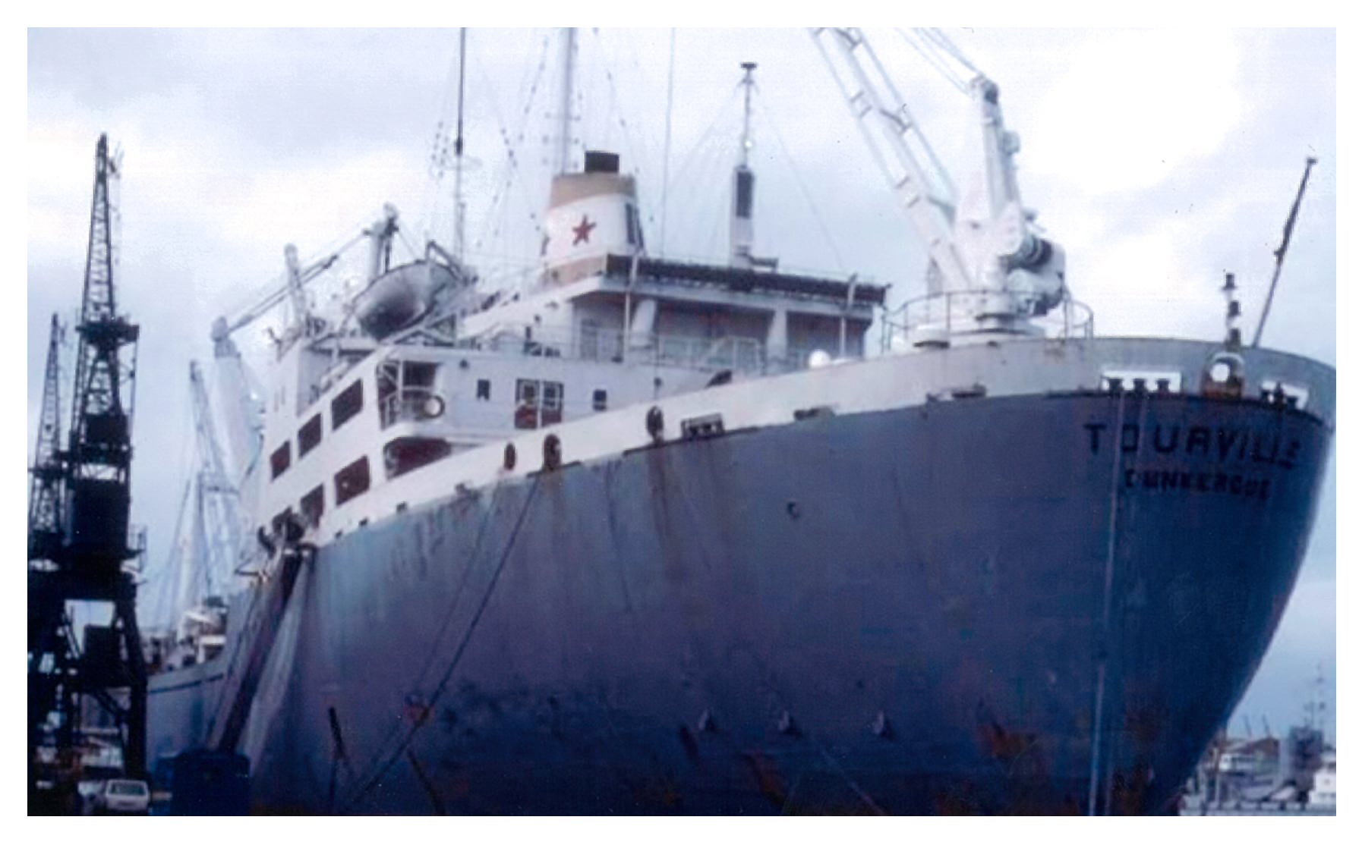
The MS Tourville of the maritime company Chargeurs Reunis, the vessel that saved our lives.

Twenty-four more hours of sea travel – on a much more comfortable, much safer, and much bigger ship – brought us to Singapore where the United Nations High Commissioner for Refugees (UNHCR) received us.

THE SINGAPORE REFUGEE CAMP.
At 7:00AM, on May 14, 1981, The Tourville arrived at Singapore and delivered to the United Nations High Commissioner for Refugees (UNHCR) fifty-four boat people it had rescued at sea the day before. A bus took us to the Refugee Camp located at 25 Hawkins Road
Sembawang, Singapore 2775
This camp was one of several refugee camps that the UNHCR had established in Southeast Asia to help resettle the Vietnamese boat people exodus after the communists took over South Vietnam in 1975. This camp was also a transit camp for the refugees from Camp Galang, Indonesia, to depart to resettlement countries.
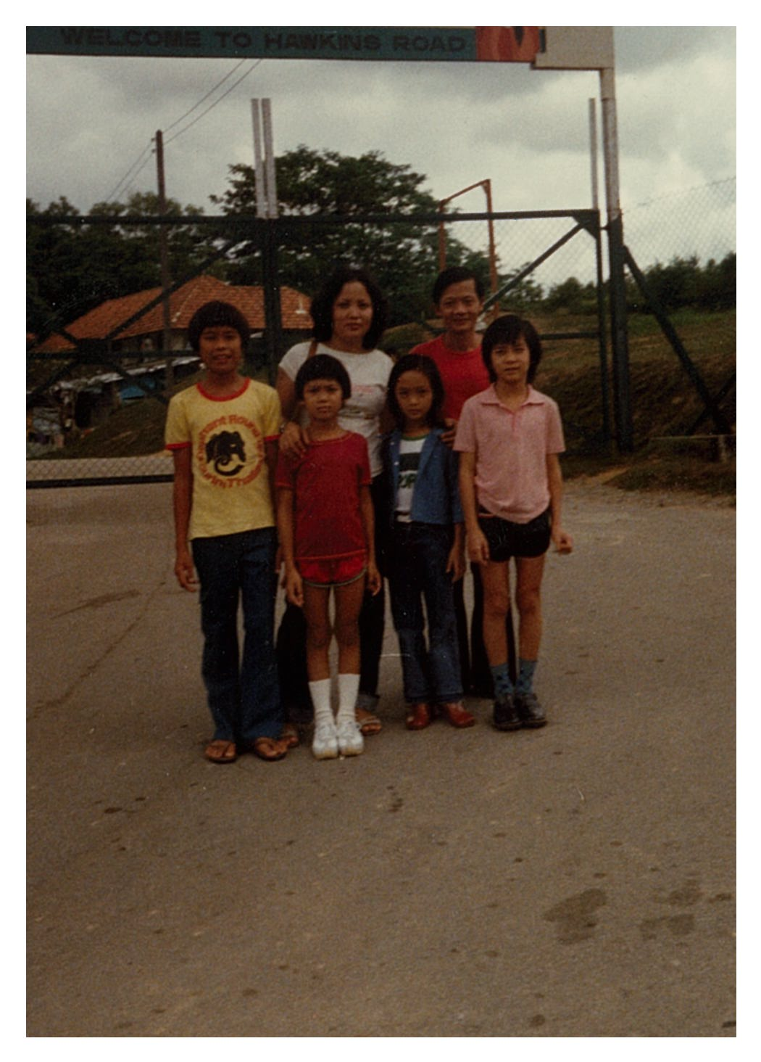
At the gate of the Singapore Refugee Camp, May 1981.
Fore-ground, from left: Ngoc Le, my wife’s cousin, Quoc Viet, my son, Thuy Tien, my daughter,
Tuan Nguyen, my wife’s nephew.
Back-ground, from left: Nhon Nguyen, my wife, and me.
Not everyone in our group, which the Singapore UNHCR officials designated The Tourville Group, would resettle in the same country and would leave the camp at the same time, due to particular family reunion factors and other criteria. My family, who applied for resettlement in the USA and was accepted, was the last people of our group to leave Singapore. During our five-month stay there, I volunteered to help the UNHCR office with its everyday activities: most of the time I took the applicants to the involved ambassies to complete their immigration paper works. Sometimes, I took a sick camp member to a hospital downtown Singapore for emergency treatment.
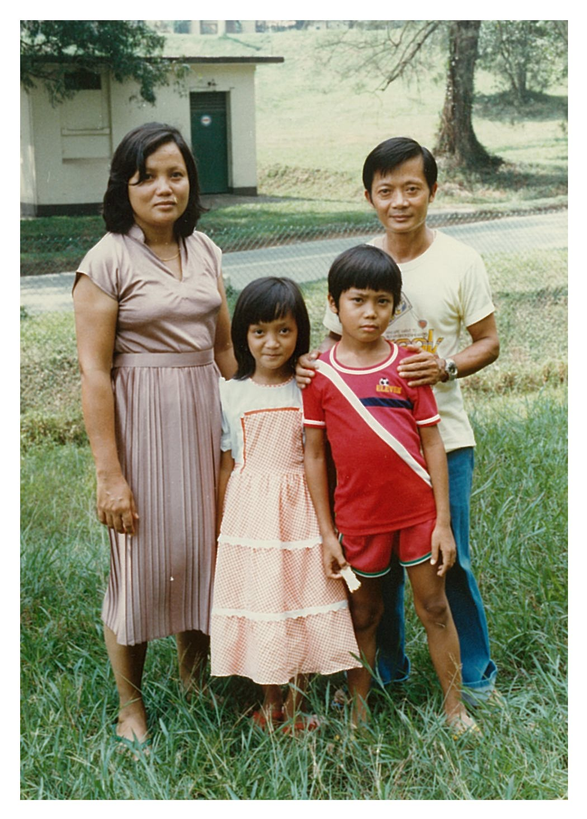
From left: Nhon Nguyen, my wife, Thuy Tien, my daughter, Quoc Viet, my son, and me.
(Singapore Refugee Camp, May 1981)
The Singapore Refugee Camp was unique of its kind. All the boat people arriving there were rescued at sea by ships on their way to Singapore, and each rescued group was given the name of the ship that had saved it for its designation. For exemple, my group’s designation was Tourville. Refugees at Singapore camp did not receive food allowance like their counterparts at other camps in Southeast Asia. Instead, they received money allowance weekly to buy their own food. There were two grocery stores on camp site to serve the camp population with its basic needs. There was a dispensary in the camp to provide medicines and first-aid treatments to refugees. The camp also had English classes for adults and children, and their teachers were the wives of foreign personnels stationed in Singapore; they volunteered to help the UNHCR. Everyday, from 10:00 AM. to 10:00 PM,
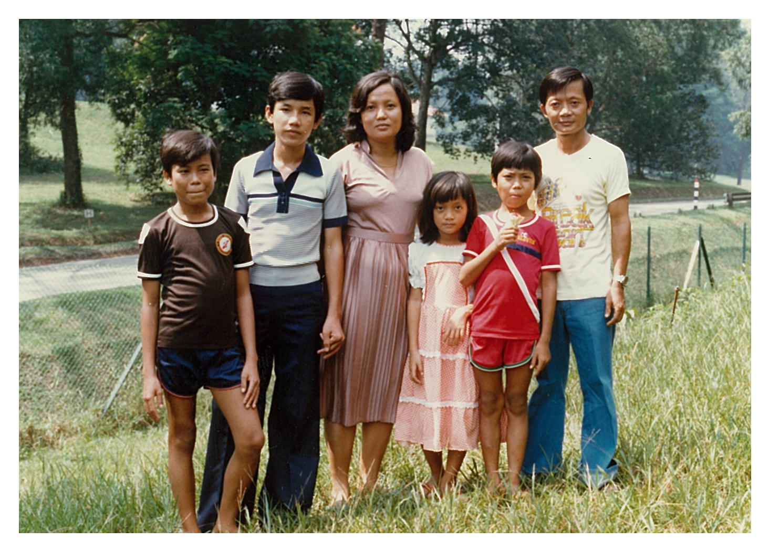
From left: Ngoc Le, my wife’s cousin, Phu Nguyen, my brother-in-law, Nhon Nguyen, my
wife, Thuy Tien, my daughter, Quoc Viet, my son, and me.

camp members can leave the camp to go everywhere in Singapore, and even can cross the bridge to Malaysia, for pleasure, for shopping , etc… A remarkable thing about Singapore Refugee Camp was that its boat people had to be resettled in the countries where their rescue-ship belonged to, unless they were eligible for family reunion elsewhere. As such, many Republic of Viet Nam Armed Forces (RVN Armed Forces) veterans winding up in Singapore Refugee Camp found no ways to seek asylum in USA just because they had not been rescued by a US ship, or had no relatives in America who were qualified for family-reunion sponsorship. That was exactly my case. But, fortunately, the fact that I had been a former RVN Special Forces soldier fit me for category 2 (Vietnameses closely co-operating with the US in war time) which met a US immigration requirement to be granted asylum in USA. Category 3 (former RVN Armed Forces pesonnels) was not applied for US resettlement at Singapore refugee camp, although it was applied at other refugee camps in Thailand, Indonesia, Malaysia, the Philippines, etc. .
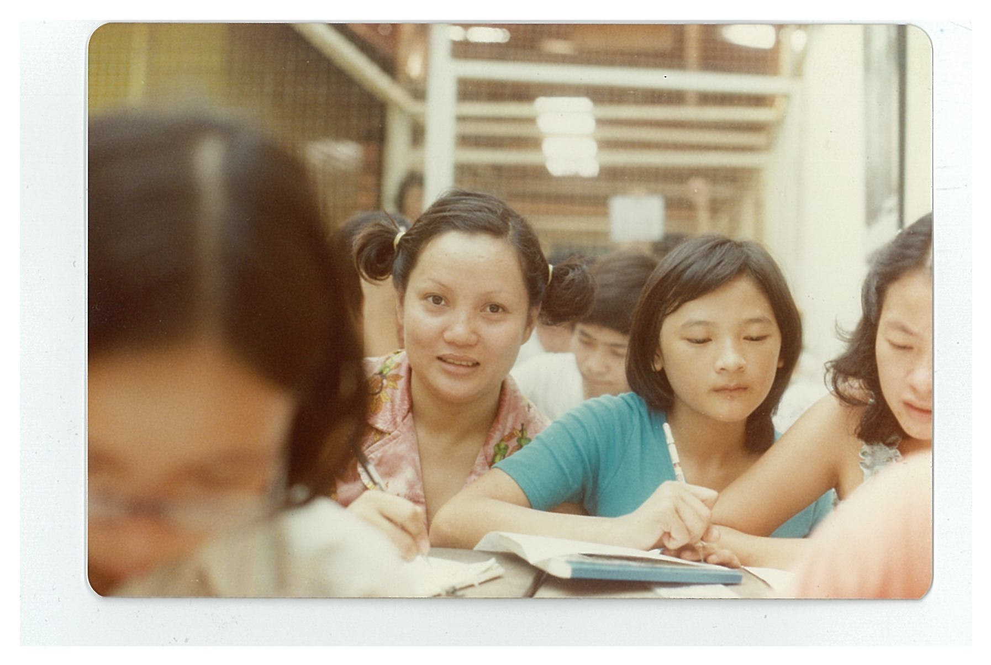
My wife (middle) attending an English class at Singapore Refugee Camp (June 1981)

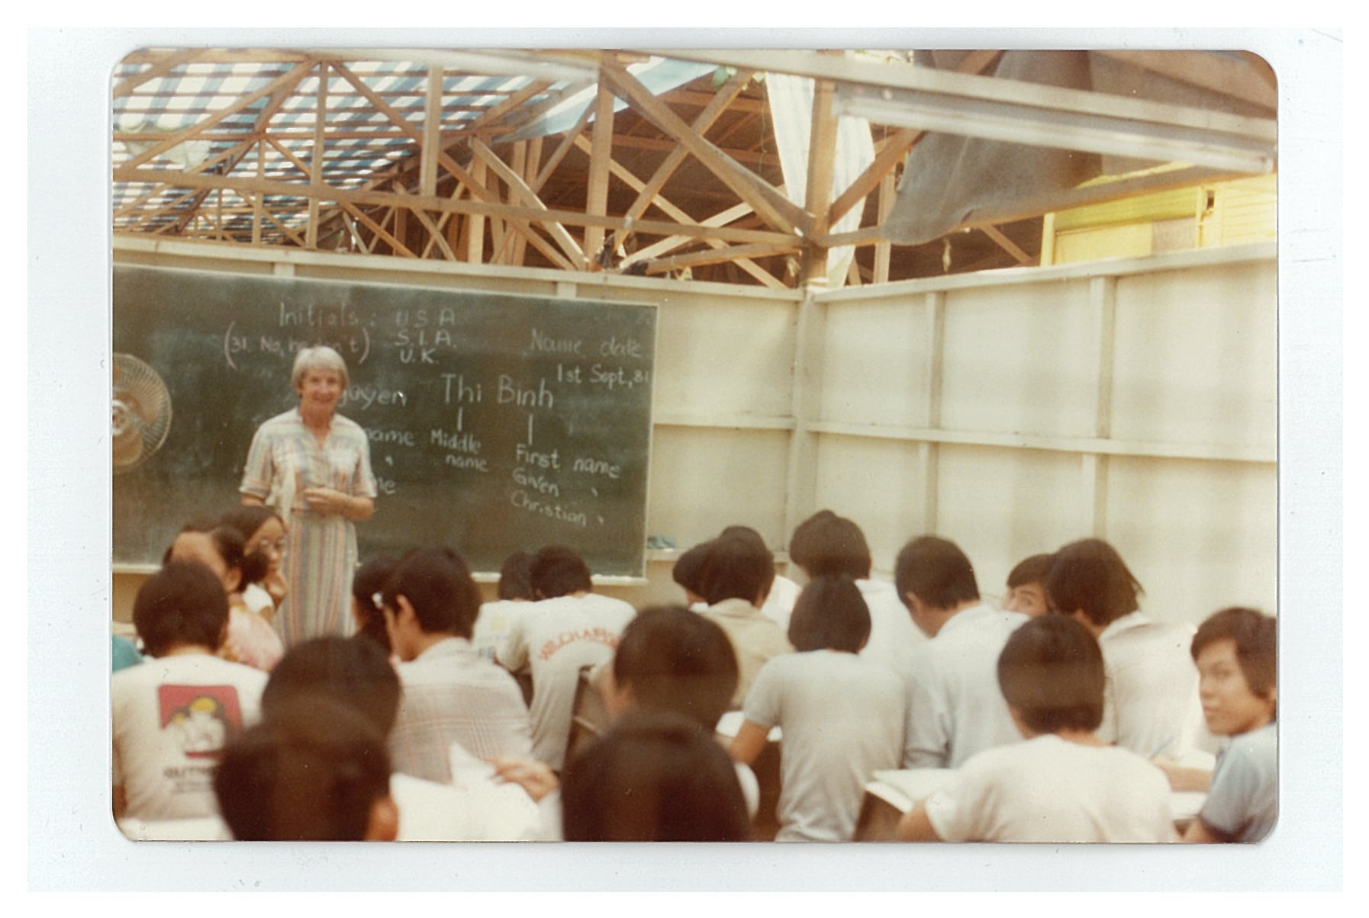
This teacher was a volunteer from New Zealand (Singapore June 1981)
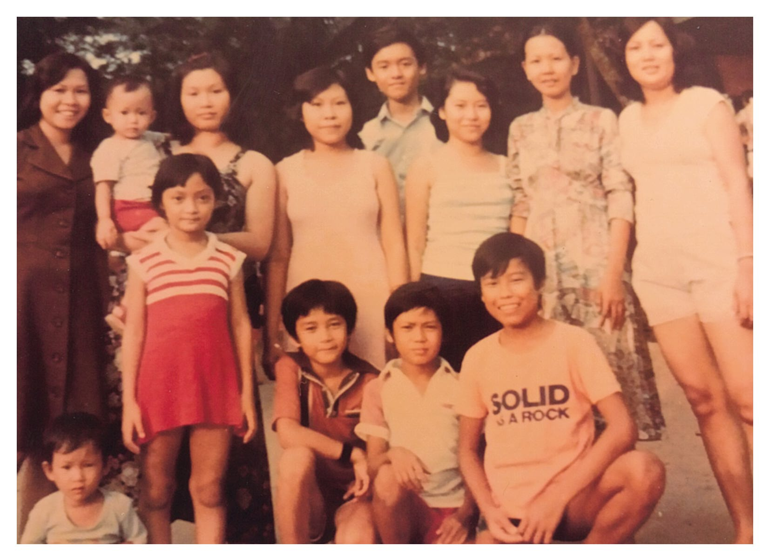
Fore-ground, from right: Ngoc Le, my wife’s cousin, Quoc Viet, my son, Tuan Nguyen, my wife’s nephew, and Thuy Tien, my daughter.
Back-ground, from right: Nhon Nguyen, my wife, Tuyet Tran, my niece, and some of our boat members. (Singapore Refugee Camp, June 1981).

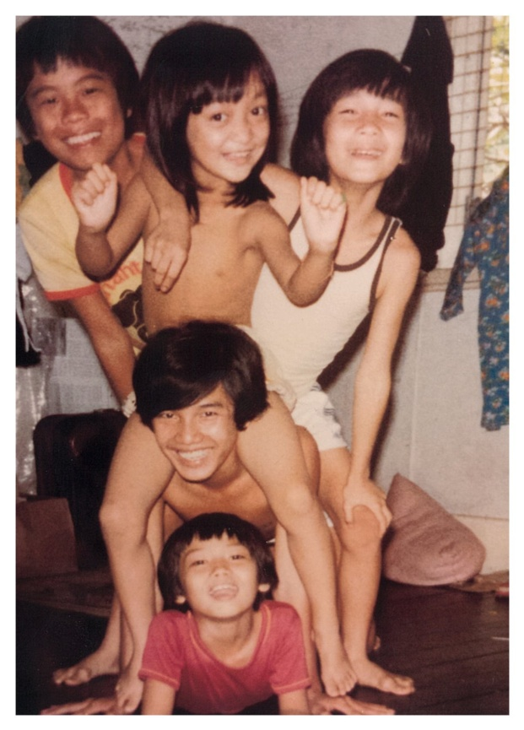
The kids enjoyed life at the Singapore Vietnamese Refugee Camp.
From bottom: Quoc Viet, Phu Nguyen, Thuy Tien, Tuan Nguyen, and Ngoc Le.
(Singapore Refugee Camp, July 1981)

The last thing, but not the least one, about The Singapore Refugee Camp I want to mention is that the camp was the most humane one as well as the best in the region. Thank you, the government and the people of Singapore! Of course, all the former Vietnamese boat people now living in different resettlement countries have been always thankful to the nations of the Southeast Asia for having provided them temporary asylums during their pursuit of freedom in the past.

TOWARDS THE NEW SHORE.
After spending five months in the refugee camp, we boarded the plane to the resettlement country.
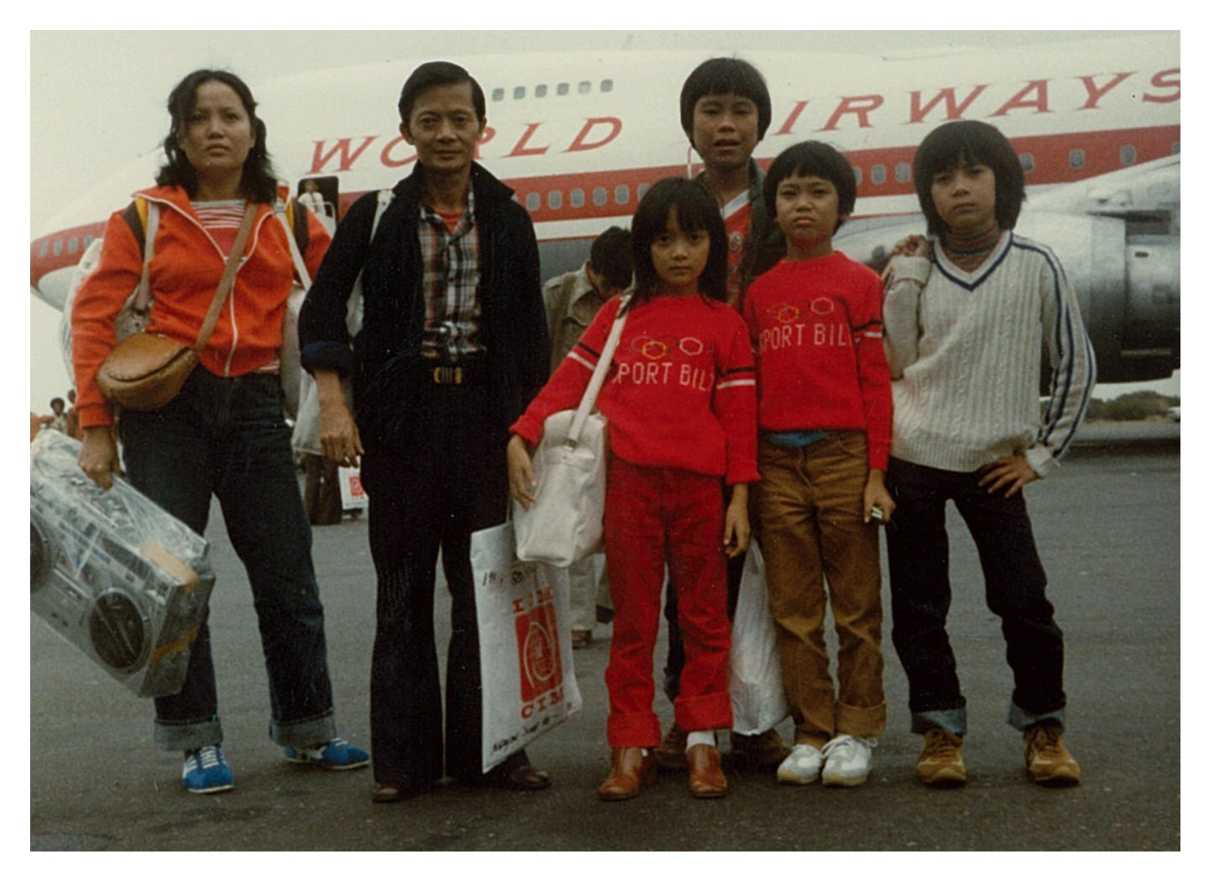
We set foot on America’s soil on 10-20-1981 via San Francisco port of entry, carrying with us
these small bags as our unique belongings, determined to rebuild our life on the new land.
(San Francisco International Airport 10-20-1981)

Leaving Singapore, our first stop in the pursuit of freedom, we were off towards the new shore, Philadelphia, Pennsylvania. We set foot on America’s soil on October 20, 1981 through San Francisco port of entry, thus Philadelphia the day after. Thank you, America, for having given us the opportunity to rebuild our life in a new society we love.

March 1982
Revised May 2014
Ha Ky Lam

- MY 7-MEMBER FAMILY LEFT VIETNAM ON MAY 9, 1981, IN A SMALL BOAT, TOGETHER WITH 47 PEOPLE

- OUR BOAT WAS RESCUED ON MAY 13, 1981 BY A MERCHANT VESSEL

- THE RESCUED BOAT PEOPLE ARRIVED AT SINGAPORE REFUGEES CAMP ON MAY 14, 1981

- MY FAMILY ARRIVED IN USA ON OCTOBER 20, 1981

